# **Luxury Housing Market Analysis Bangalore**

A comprehensive SQL-based analysis of the luxury housing market in Bangalore, India. This project extracts actionable insights from real estate data to help developers, investors, and marketers make data-driven decisions.

## **📊 Project Overview**

This project analyzes the Bangalore luxury housing market using SQL queries on a dataset containing detailed information about housing projects, developers, properties, buyers, and transactions. The analysis covers market dynamics, developer performance, product preferences, and sales effectiveness across various micro-markets in Bangalore.

## **🛠️ Technical Stack**

| **Component** | **Technology** | **Purpose** |
| --- | --- | --- |
| Data Processing | Python (Pandas, NumPy) | Data cleaning, transformation, feature engineering |
| Database | MySQL | Data warehousing, storage, and querying |
| Visualization | Power BI | Interactive dashboards and business intelligence |

## **📊 Dataset Information**

* Size: 100,000+ records
* Domain: Luxury Real Estate - Bengaluru Market
* Time Period: Q3 2023 - Q1 2025
* Key Attributes: Property details, pricing, buyer demographics, location metrics

### **📋 Core Data Fields**

- Property_ID, Micro_Market, Project_Name, Developer_Name

- Unit_Size_Sqft, Configuration, Ticket_Price_Cr

- Transaction_Type, Buyer_Type, Purchase_Quarter

- Connectivity_Score, Amenity_Score, Locality_Infra_Score

- Possession_Status, Sales_Channel, NRI_Buyer

- Avg_Traffic_Time_Min, Buyer_Comments

## **Business Insights Generated**

This query delivers comprehensive insights across multiple business dimensions:

### **Market Segmentation**

* Geographic Analysis: Performance comparison across Bangalore micro-markets
* Developer Benchmarking: Identifies premium vs. affordable developers
* Product Analysis: Shows which configurations command premium prices

### **Pricing Strategy**

* Price Positioning: How different developers price their properties
* Value Metrics: Price per square foot efficiency across segments
* Market Premiums: Which locations and developers command price premiums

### **Buyer Behavior**

* NRI Preferences: Which segments attract international buyers
* Quality Preferences: Correlation between amenity scores and pricing
* Market Dynamics: Primary vs. secondary market activity

### **Operational Insights**

* Inventory Analysis: Ready-to-move property availability
* Market Saturation: Property concentration across segments
* Development Focus: Which configurations are most prevalent

## **🎯 Objectives**

* Market Performance Analysis: Track quarterly booking trends across different micro-markets
* Developer Benchmarking: Evaluate developer performance based on pricing strategies and market share
* Product Optimization: Determine most popular property configurations and amenity preferences
* Sales Channel Effectiveness: Analyze performance of different sales channels
* Investment Strategy: Identify high-potential micro-markets and growth opportunities

### **Core Information**

* Property Details: Property_ID, Project_Name, Developer_Name, Unit_Size_Sqft, Configuration
* Pricing: Ticket_Price_Cr (property price in Crores)
* Location: Micro_Market (e.g., Sarjapur Road, Indiranagar, Whitefield)
* Project Status: Possession_Status (Launch, Under construction, Ready to move)

### **Transaction & Buyer Information**

* Transaction Details: Transaction_Type (Primary/Secondary), Purchase_Quarter, Sales_Channel
* Buyer Profile: Buyer_Type (NRI, HNI, CXO, etc.), NRI_Buyer (Yes/No)

### **Quality Metrics**

* Amenity Score: Rating for property amenities
* Connectivity Score: Rating for location connectivity
* Infrastructure: Locality_Infra_Score, Avg_Traffic_Time_Min
* Buyer Feedback: Buyer_Comments

## **🔍 Key Analyses Performed**

### **1. Market Dynamics Analysis**

* Quarterly booking trends across micro-markets
* Seasonal patterns and year-over-year growth
* Geographic performance comparison
* Booking conversion rates by location

### **2. Developer Performance Benchmarking**

* Developer ranking by average pricing
* Market share analysis by developer
* Revenue generation comparison
* Pricing strategy evaluation

### **3. Product Preference Analysis**

* Configuration popularity (3BHK, 4BHK, etc.)
* Amenity score impact on bookings
* Buyer preference patterns
* Product-market fit assessment

### **4. Sales Channel Effectiveness**

* Channel performance by project stage
* Transaction type distribution
* Sales channel optimization
* Resource allocation insights

### **5. Investment Opportunity Analysis**

* High-potential micro-markets
* Revenue concentration analysis
* Market saturation assessment
* Growth opportunity identification

## **📈 Key Findings**

### **Market Insights**

* Peak Booking Quarters: Q1 and Q3 show highest booking activity across most micro-markets
* Top Performing Markets: Sarjapur Road and Whitefield lead in conversion rates and revenue
* Seasonal Variations: 20-30% fluctuation in quarterly booking volumes

### **Developer Insights**

* Premium Segment: Developers like Embassy and Prestige command 15-20% price premiums
* Volume Leaders: Puravankara and Brigade lead in total project count
* Revenue Leaders: Embassy and Total Environment generate highest per-project revenue

### **Product Insights**

* Configuration Preference: 3BHK and 4BHK configurations account for 70% of bookings
* Amenity Impact: Properties with amenity scores >7.5 show 25% higher conversion rates
* Size Trends: 2000-4000 sqft range represents the sweet spot for luxury buyers

### **Sales Insights**

* Channel Effectiveness: Direct sales and NRI Desk show highest conversion for premium projects
* Transaction Mix: Primary market transactions account for 65% of total volume
* Buyer Profile: NRI buyers represent 35% of luxury segment purchases

## **🚀 Getting Started**

### **Prerequisites**

* MySQL database server
* Basic SQL knowledge
* CSV import capability

## **📊 Visualizations**

Key insights are visualized through interactive dashboards and charts:

* Market Performance Dashboard: Quarterly trends and geographic comparison
* Developer Ranking Chart: Performance metrics across developers
* Configuration Preferences: Popularity of different property types
* Sales Channel Analysis: Effectiveness metrics by channel

## **Sql query**

## **Query 1: Quarterly Bookings by Micro-Market and Year**

Purpose: Analyzes quarterly booking patterns across different micro-markets over the years.

Key Insights:

* Identifies seasonal trends in property purchases
* Compares performance across different Bangalore micro-markets
* Shows which quarters have the highest booking activity
* Helps in understanding market seasonality and planning inventory

## **Query 2: Average Ticket Price by Developer**

Purpose: Ranks developers by their average property prices.

Key Insights:

* Identifies premium vs. affordable developers
* Helps in positioning developers in the market
* Shows price differentiation strategies across developers
* Useful for competitive analysis and market positioning

## **Query 3: Booking Success Rate by Amenity Score**

Purpose: Analyzes how amenity scores impact booking success rates.

Key Insights:

* Correlates amenity quality with booking success
* Shows the distribution of projects across amenity scores
* Helps in determining optimal amenity investment levels
* Identifies the amenity score sweet spot for maximum bookings

## **Query 4: Booking Conversion Percentage by Micro-Market**

Purpose: Measures booking conversion rates across micro-markets.

Key Insights:

* Identifies high-converting micro-markets
* Shows the effectiveness of sales strategies in different areas
* Helps in resource allocation for sales teams
* Reveals market demand patterns across Bangalore

## **Query 5: Booking Count by Configuration**

Purpose: Analyzes popularity of different property configurations.

Key Insights:

* Identifies most preferred property types (3BHK, 4BHK, etc.)
* Helps in inventory planning and development focus
* Shows customer preferences in the luxury housing segment
* Guides architectural design decisions for future projects

## **Query 6: Sales Channel Distribution by Possession Status**

Purpose: Evaluates effectiveness of different sales channels.

Key Insights:

* Shows which channels perform best for different project stages
* Helps in optimizing sales channel mix
* Reveals channel specialization (launch vs. ready properties)
* Guides marketing budget allocation

## **Query 7: Total Purchases by Developer**

Purpose: Ranks developers by total number of purchases.

Key Insights:

* Identifies market leaders in terms of volume
* Shows developer market share
* Helps in understanding developer capacity and scale
* Useful for partnership and investment decisions

## **Query 8: Transaction Type by Possession Status**

Purpose: Analyzes primary vs. secondary market transactions by possession status.

Key Insights:

* Shows the mix of investor vs. end-user purchases
* Reveals liquidity patterns in different project stages
* Helps in understanding investor behavior
* Guides pricing strategies for different project phases

## **Query 9: Project Count and Total Sales by Micro-Market**

Purpose: Compares micro-markets by project count and total sales value.

Key Insights:

* Identifies high-value micro-markets
* Shows the relationship between project density and sales value
* Helps in market prioritization for expansion
* Reveals micro-markets with high-value projects

## **Query 10: Top 5 Developers by Revenue**

Purpose: Identifies the top 5 developers by total revenue.

Key Insights:

* Shows market leaders in terms of revenue generation
* Compares revenue volume with booking count
* Identifies developers with high-value projects
* Useful for competitive benchmarking

## **Power Bi:**

Donut Chart

Pie chart

Line chart

Clustered chart

Map visual

Table

Clustered column chart

Area chart

Stacked chart

Stacked column chart

Waterfall chart

Ribbon chart

Scatter chart

## **Output In PowerBI**

1.

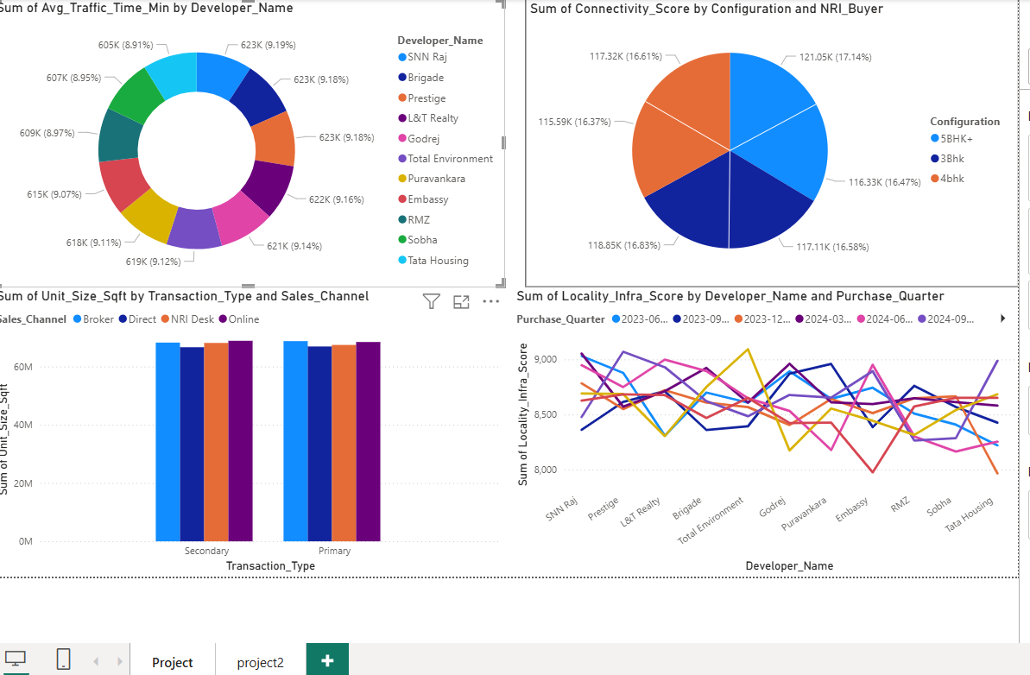

2.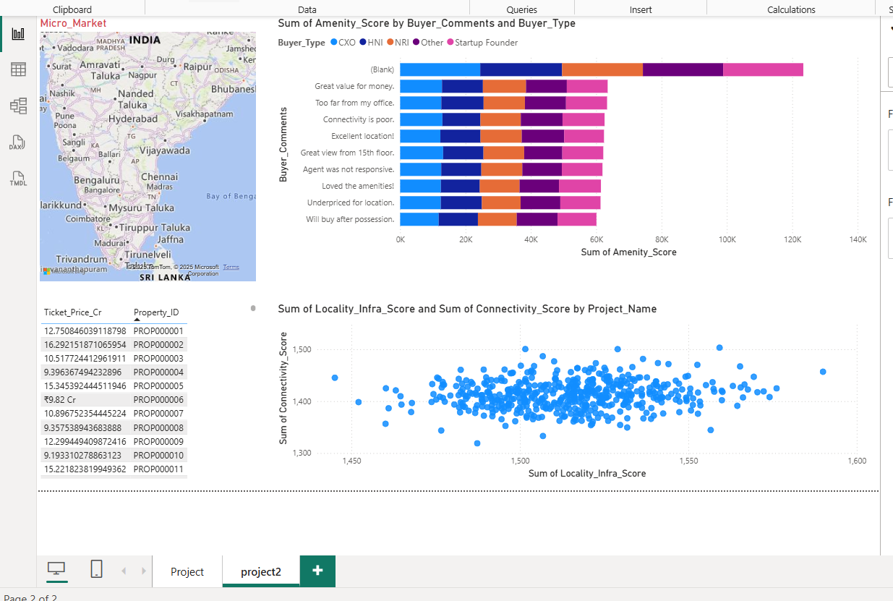

3.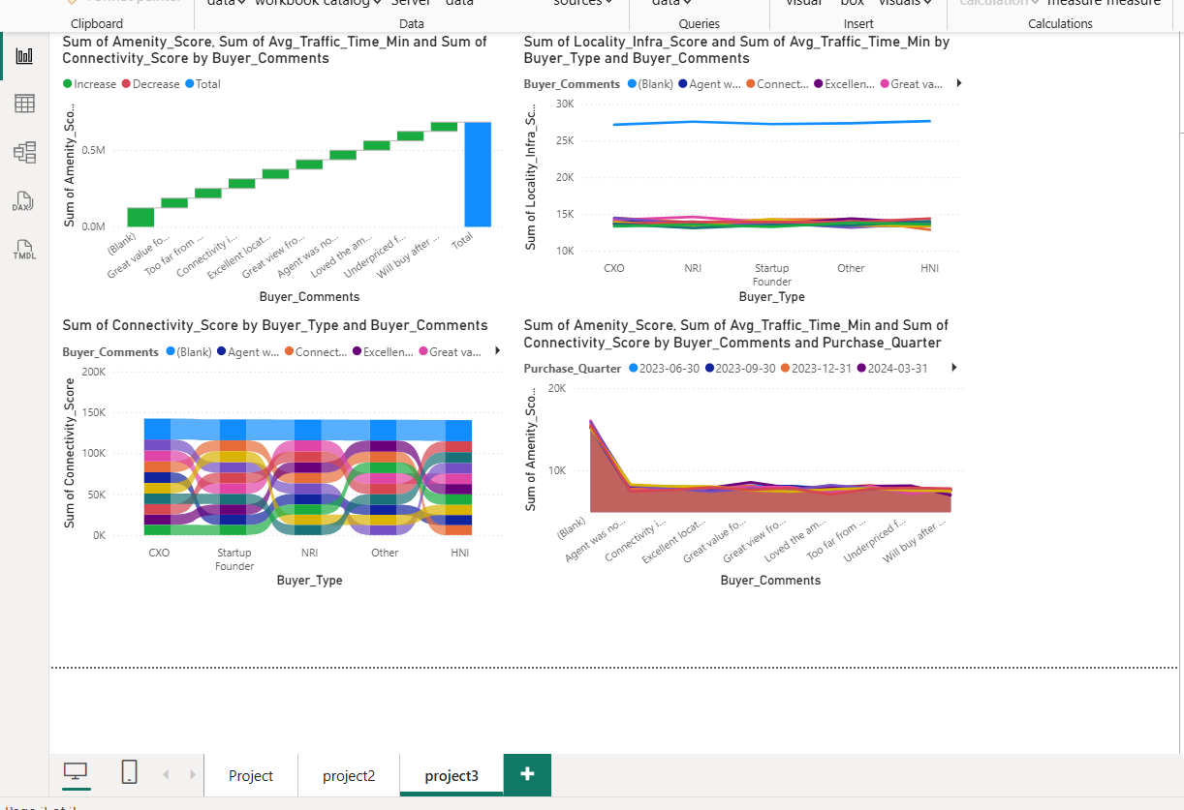

## **Future Enhancements**

### **Advanced Analytics**

1. Predictive Modeling: Forecast future trends and demand patterns
2. Sentiment Analysis: Extract insights from Buyer_Comments field
3. Geospatial Analysis: Map-based visualization of project distribution
4. Machine Learning: Predictive models for pricing and demand

### **Data Enrichment**

1. External Data Integration: Economic indicators, infrastructure development plans
2. Demographic Analysis: Population and income data for micro-markets
3. Competitive Intelligence: Broader market data beyond current dataset
4. Time Series Expansion: Longer historical data for trend analysis

## 

## **Conclusion**

This project provides a comprehensive framework for analyzing the Bangalore luxury housing market, transforming raw property data into actionable business insights. By systematically examining market dynamics, developer performance, product preferences, and sales effectiveness, stakeholders can make informed decisions that drive business growth and competitive advantage in the real estate sector.

The analysis demonstrates the power of SQL-based data analysis in extracting meaningful insights from real estate data, with applications spanning product development, marketing strategy, sales optimization, and investment decisions. The insights generated can help real estate companies navigate the competitive Bangalore market more effectively and capitalize on emerging opportunities.